This is a job aid on a few eRacer topics you may find handy.

# Creating an assignment

1. Go to my.htu.edu and login with your username and password (log into the portal).

2. Navigate to the appropriate Coursework portlet instance.

2. In the pane at the upper left, click *Coursework.*

3. Click*Add an Assignment.*A pop-up menu asks you to choose a format.

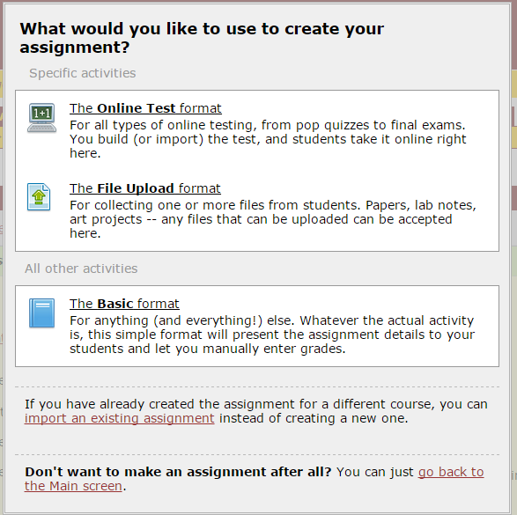

4. Choose the one that suits your purpose and fill the fields.

5. Scroll to the bottom and click *Save your new assignment.*

## Grading an assignment

1. In the pane at the upper left, click *Coursework.*
2. The main view of the portlet will flag all graded assignments along with any assignment that needs grading with an icon that looks like a calculator.



1. Click the assignment you need to grade.
2. You will be directed to a screen where you can see the list of your students.
3. Hover your cursor over individual names. A box shows up with three options to the right of the cursor:

* Full credit: clicking this gives the student the maximum point value defined for the question.
* No credit: clicking this gives the student zero points.
* Partial credit: clicking this icon lets you enter any number of points that you think is appropriate.

When you select partial credit, the system displays the *Partial Grade*pop-up. Use this pop up to enter grades.

# Gradebook

To navigate to the Gradebook portlet:

1. Log into the portal.

2. Navigate to the appropriate course section.

3. In the *Quick Links*area of the sidebar, expand the link labeled *My Courses.*

4. Select the appropriate course section.

5. In the sidebar, click the *Gradebook* page button. When you navigate to the Gradebook portlet, it displays a home screen that lists all enrolled students and non-roster students along with students’ grades so far.



If you need to see the list of all students along with their grades for each assignment and each evaluation and their overall grades in the course section so far, click the *Full Gradebook* link. Whenever you create an assignment a column is automatically created in the full gradebook for that assignment.

# Attendance

1. Navigate to the appropriate course context.
2. In the left-hand pane, select the *Attendance*page. The system displays the Attendance page, which hosts the Attendance portlet.



1. Make sure the day you are reporting the attendance for is highlighted on the calendar on the left.
2. Click individual names on the list and choose from the drop down box. Everybody is marked present by default.
3. Click Save.

## Adding a session

You may find this useful especially if you are teaching a course for Adult Degree Program (ADP).

1. Navigate to the appropriate *Attendance* portlet instance.
2. Click *Add a Session.*
3. The system displays the Attendance - Add/Edit a Sessionscreen.
4. Fill out the form as appropriate.
5. Click *Save*. The system adds the session to the calendar.

You can add multiple sessions for one single day if you need to. Remember you need to click *Save* every time you add a session. Once you are done adding sessions, click the specific day on which you added sessions. You will see a list of all the sessions along with students’ names.

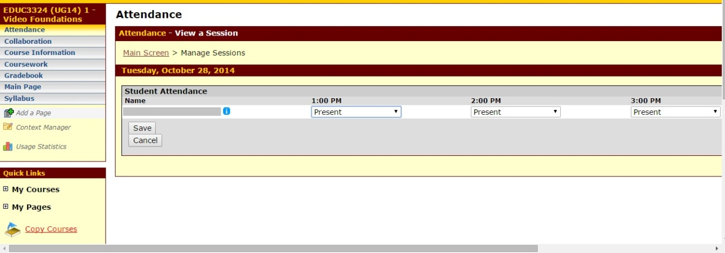

# Grade Entry

To enter midterm and final grades:

1. Navigate to the appropriate Coursework portlet instance.
2. Click *Faculty* tab at the top of the screen.
3. Click *View Course List* in *Grade Entry* (middle of the screen) box.
4. Make sure you choose the right term/semester from the drop down box on the right. It is on the current semester by default.

Note: If you are entering grades for an ADP course, make sure you choose CF for the fall semester or CS for the spring semester from the drop down box and click *Search.*

1. Choose the course whose grades you need to enter.
2. You will be directed to a screen where you can see the list of the students. From the drop down box in front of every student’s name, choose the grade they have made in the course and submit the grades once you are done.

# Adding handouts to Main Page

1. Navigate to the appropriate Coursework portlet instance.
2. Click *Add a Handout* link. (right)
3. Fill the fields, upload the file and click *Save*.

Note: It is a good idea to create different categories for your handouts to be more organized. To do so, click *Add a Set* link to create a folder for handouts which can be put in the same group. Fill the fields and click *Save*. Every time you add a handout, make sure you choose the right set/category for it.